Financial Risk Analytics with Polyglot Data Engineering
A Project Based Learning Report Submitted in partial fulfilment of the requirements for
the award of the degree
of
Bachelor of Technology
in The Department of Artificial Intelligence & Data Science
25CS1302E – DBE & DSD
Submitted by
2510080004: UTKALIKA
2510080025: DIVYA SRI
2510080033: KAVITHA
2510080035: AMBIKA
Under the guidance of
Dr. LAIPHANGBAM MELINDA

Department of Electronics and Communication Engineering
Koneru Lakshmaiah Education Foundation, Aziz Nagar
Aziz Nagar – 500075
OCTOBER - 2026

ABSTRACT
Financial institutions process structured customer, account, and transaction records while also needing flexible storage for risk indicators and analytical results. The project “Financial Risk Analytics with Polyglot Data Engineering” implements a DBMS-centered prototype that separates these workloads between PostgreSQL and MongoDB. PostgreSQL acts as the relational source of truth for customer, account, and transaction data, while MongoDB stores risk-analysis documents containing the calculated score, risk level, and indicators.
The implemented backend is developed with FastAPI and exposes REST endpoints for login, customer management, account management, deposits, withdrawals, transaction retrieval, and risk analysis. JWT-based authentication is used to protect the application endpoints. The frontend is implemented using HTML, CSS, and JavaScript and provides pages for login, dashboard, customers, accounts, transactions, and risk analysis. The current risk engine is rule-based: a transaction amount above 50,000 adds 50 points, a frequency above 10 adds 30 points, and the final score maps to LOW, MEDIUM, or HIGH risk. This design demonstrates how relational integrity, document flexibility, API security, and operational risk analysis can be combined in a single project workflow.

LIST OF FIGURES
FIGURE NO. | FIGURE TITLE
Figure 1 | Implemented System Architecture
Figure 2 | End-to-End Data and Risk Analysis Lifecycle
Figure 3 | Project Data Model and Polyglot Persistence
Figure 4 | Implemented Rule-Based Risk Scoring
Figure 5 | Risk-Level Rule Coverage
Figure 6 | Login Interface
Figure 7 | Dashboard Interface
Figure 8 | Risk Analysis Interface
Figure 9 | Swagger UI
Figure 10 | Successful login and JWT token genaration
Figure 11 | Swagger HTTPBearer Authorization

LIST OF TABLES
TABLE NO. | TABLE TITLE
Table 1 | Project Technology Stack
Table 2 | Core Relational Data Model
Table 3 | MongoDB Risk Document Structure
Table 4 | REST API Endpoints
Table 5 | Risk-Scoring Rules
Table 6 | Functional Test Cases
Table 7 | Project Results and Verification

TABLE OF CONTENTS
SECTION | PAGE
1. INTRODUCTION | 6
2. METHODOLOGY | 12
2.1 Project Architecture and Technology Selection | 12
2.2 Relational Data Management | 13
2.3 Document-Based Risk Storage | 14
2.4 Authentication and API Security | 14
2.5 Frontend Methodology | 15
3. EXPERIMENTS | 20
4. RESULTS | 44
5. CONCLUSION AND FUTURE WORK | 45
References | 56

Financial Risk Analytics with Polyglot Data Engineering

1. INTRODUCTION
Financial risk analytics requires more than calculating a numerical risk value. A practical financial information system must maintain reliable customer and account records, preserve transaction history, validate relationships between records, protect sensitive operations, and provide flexible storage for analytical outputs. The project addresses these requirements through a polyglot data-engineering approach in which each database is assigned a workload that matches its strengths.

The project uses PostgreSQL as the relational core. Customer, account, and transaction records are treated as structured data, with account records linked to customers and transactions linked to accounts. The application code performs inserts, reads, balance updates, transaction logging, and account deletion through PostgreSQL connections. Deposit and withdrawal operations update account balances and create corresponding transaction records. Withdrawal processing additionally checks the available balance before completing the operation.
MongoDB is used as the analytics document store. The implemented risk module calculates a score from transaction amount and transaction frequency and then stores a document containing customer ID, account ID, risk score, risk level, and risk indicators. This flexible document structure is suitable for adding new indicators without changing the relational ledger tables.
The application layer is implemented with FastAPI. Pydantic request models define the expected structure for login, customers, accounts, transactions, and risk-analysis requests. JWT authentication is applied through HTTP Bearer tokens. The login endpoint accepts the configured demonstration credentials and returns a token, while protected endpoints depend on token verification.
A browser-based frontend provides the operational interface. The project contains separate HTML pages for login, dashboard, customers, accounts, transactions, and risk analysis. JavaScript functions communicate with the FastAPI backend using fetch requests, store the JWT token in local storage, render returned records in tables, and display risk results to the user. The interface therefore connects the DBMS layer, backend services, authentication mechanism, and risk-analysis function into one demonstrable workflow.
The PPT frames the broader project vision as “From Financial Data to Risk Intelligence” and identifies fragmented data, single-database bottlenecks, and opaque risk insights as the main challenges. The implemented prototype directly addresses these themes through PostgreSQL for structured financial records, MongoDB for risk documents, a FastAPI service layer, and authenticated REST endpoints. Some PPT items such as Kafka streaming, SHAP/LIME explainability, cloud clustering, and automated compliance reporting are treated as future extensions rather than implemented features.
Financial institutions and banking-related systems handle large amounts of data every day. This data includes customer information, account details, transaction records, account balances, and other information required for monitoring financial activities. As the amount of financial data increases, storing, organizing, retrieving, and analyzing this information efficiently becomes an important requirement. A financial system must not only maintain accurate records but should also provide meaningful information that can help identify potentially risky activities.
Financial risk analytics focuses on analyzing financial information to identify patterns and indicators that may represent risk. In a traditional database system, most of the information is stored in a structured format. Customer records, account records, and transaction records are generally related to one another. For example, a customer may have one or more accounts, and each account may contain multiple transactions. Maintaining these relationships correctly is essential because incorrect or inconsistent data can affect account balances and risk analysis.
The project “Financial Risk Analytics with Polyglot Data Engineering” addresses this requirement by using two different types of databases for different purposes. PostgreSQL is used as the relational database and acts as the main source of truth for customer, account, and transaction information. MongoDB is used as a document-based database for storing risk-analysis results. This approach separates operational financial data from flexible analytical risk information.

The use of multiple database technologies in a single application is commonly referred to as a polyglot data approach. In this project, the purpose is not simply to use multiple databases, but to assign each database a suitable responsibility. PostgreSQL is appropriate for structured information and relationships between entities, while MongoDB provides a flexible structure for storing risk-analysis documents. This separation helps demonstrate how different data-management technologies can work together within one application.

The project also includes a FastAPI-based backend that acts as the application layer between the frontend and databases. The backend provides REST API endpoints for different operations such as login, customer management, account management, deposits, withdrawals, transaction retrieval, and risk analysis. The API receives requests from the frontend, processes them, interacts with the appropriate database, and sends the required response.

Security is another important part of the system. Since the application deals with financial information, access to protected operations should not be available to unauthorized users. The project therefore uses JWT-based authentication with HTTP Bearer tokens. A user first logs in using valid credentials. After successful authentication, the backend generates a JWT token. This token is then used when accessing protected API endpoints. Invalid or expired tokens result in an unauthorized response.

The frontend of the application is developed using HTML, CSS, and JavaScript. It provides pages for login, dashboard information, customers, accounts, transactions, and risk analysis. JavaScript is used to communicate with the FastAPI backend through REST API calls. The authentication token is stored in the browser's local storage and is included when protected requests are made.
The project uses PostgreSQL as the relational database for storing the main financial records. Customer, account, and transaction information are maintained in PostgreSQL. These records have clear relationships and structured fields, making a relational database suitable for the operational part of the system.
For storing risk-analysis results, the project uses MongoDB. Risk results are represented as documents containing information such as customer ID, account ID, risk score, risk level, and risk indicators. MongoDB provides a document-oriented structure that can store this type of analytical result flexibly.
This combination of PostgreSQL and MongoDB forms the basis of the project's polyglot data engineering approach. The purpose is to demonstrate how different data storage technologies can be integrated within one application and assigned different responsibilities according to the nature of the data.

1.2 Background of the Project
Financial data is one of the most important forms of data handled by modern information systems. A financial application may need to maintain information about customers, accounts, transactions, balances, and risk-related activities. Such information must be stored accurately because even a small inconsistency can affect subsequent financial operations and analysis.
In a typical financial application, customer information is connected to accounts, and accounts are connected to transactions. For example, a customer may own one or more accounts, while each account may have multiple deposits and withdrawals. Therefore, the system must maintain relationships between these entities.
Relational database systems are well suited for this type of structured information. In this project, PostgreSQL is used to maintain the relational financial data. The core relational entities include:
- Customer
- Account
- Transaction
The Customer entity contains customer identification and contact information such as customer ID, name, email, and phone number.
The Account entity contains account-related information such as account ID, customer ID, account type, and balance.
The Transaction entity stores transaction information including transaction ID, account ID, transaction type, and amount.
These entities are related to each other and form the operational foundation of the application.
However, financial applications also need to generate analytical information from the operational data. Risk-analysis results may contain a score, risk level, and several risk indicators. Such information can be represented naturally as a document.
For this reason, the project introduces MongoDB as the document-oriented component of the architecture. Instead of storing risk-analysis results in the same relational structures as the operational data, the system stores them in a MongoDB collection named risk_analysis.
This separation of responsibilities is the central concept of the project.
The project therefore follows the idea:
Structured Financial Data → PostgreSQL
and
Risk Analysis Results → MongoDB
This approach demonstrates how multiple database technologies can be used together based on the characteristics of the data.

1.3 Need for Financial Risk Analytics
Financial transaction systems generate large amounts of operational data. Simply storing this data is not always sufficient. The stored information can also be examined to identify activities that may require additional attention.
Risk analysis provides a way of converting transaction information into meaningful indicators. Instead of viewing each transaction independently, the system can consider characteristics such as transaction amount and transaction frequency.
In the current project, two simple indicators are used:
- High transaction amount.
- High transaction frequency.
A transaction amount greater than 50,000 contributes 50 points to the risk score. A transaction frequency greater than 10 contributes another 30 points.
The resulting score is then mapped to a risk level.
This provides a simple and transparent method for demonstrating financial risk analysis.
The need for such analysis can be understood through the following points:
- Financial applications generate continuous transaction information.
- Raw transaction records alone do not directly communicate risk.
- Risk indicators help organize potentially important activity.
- A scoring mechanism makes risk information easier to interpret.
- Storing risk results separately allows analytical information to be accessed independently.
- A clear rule-based approach makes the current prototype easy to understand and demonstrate.
The project therefore focuses on connecting data management with risk intelligence rather than treating database operations and analytics as completely separate activities.

1.4 Problem Statement
The main problem addressed by this project is the need to design a financial application that can manage structured financial data while also generating and storing flexible risk-analysis information.
A simple single-database approach may not always provide the most suitable representation for every type of data. Customer, account, and transaction records have clearly defined relationships and therefore require structured relational management. On the other hand, risk-analysis output can contain analytical attributes that are naturally represented as documents.
The project therefore addresses the following problem:
“How can structured financial information and flexible risk-analysis results be managed efficiently within a single application using multiple database technologies while maintaining authentication, transaction validation, and a clear risk-analysis workflow?”
The project approaches this problem through a polyglot persistence architecture.
The major requirements are:
- Store customer information reliably.
- Maintain relationships between customers and accounts.
- Maintain account balances and transaction history.
- Support deposit and withdrawal operations.
- Validate financial operations.
- Protect application operations using authentication.
- Analyze financial activity using defined risk rules.
- Generate a risk score and risk level.
- Store risk-analysis results separately in MongoDB.
- Provide a frontend through which users can interact with the system.
The project is therefore not limited to database storage. It combines database management, API development, security, financial processing, and risk analytics into one system.

1.5 Project Vision
The overall vision of the project is:

“From Financial Data to Risk Intelligence.”
The purpose of this vision is to demonstrate how ordinary financial records can be transformed into meaningful risk information.
The system begins with structured data such as:
- Customer information.
- Account information.
- Transaction information.
- Transaction amount.
- Transaction frequency.
This information is processed by the application and evaluated using predefined risk rules. The result is converted into:
- Risk score.
- Risk level.
- Risk indicators.
The final risk result is then stored in MongoDB.
The complete conceptual flow is:
Customer and Account Data
↓
Financial Transactions
↓
Transaction Data in PostgreSQL
↓
Risk Evaluation
↓
Risk Score
↓
Risk Level and Indicators
↓
MongoDB Risk Document
This vision demonstrates the transition from simple data storage toward analytical decision support.

1.6 Objectives of the Project
The primary objective of the project is to develop a DBMS-centered financial risk analytics prototype using a polyglot persistence architecture.
The major objectives are described below.

Objective 1: Implement Relational Financial Data Management
The project aims to use PostgreSQL for maintaining structured customer, account, and transaction information.
This provides a reliable relational foundation for the application.

Objective 2: Implement Document-Based Risk Storage
The project aims to use MongoDB for storing generated risk-analysis results.
This demonstrates how document-oriented storage can be used for analytical outputs.

Objective 3: Develop REST APIs
FastAPI is used to create REST endpoints for application operations such as login, customer management, account management, transaction processing, and risk analysis.

Objective 4: Implement Authentication
JWT-based authentication is implemented to protect application operations.
The authentication mechanism provides a basic security layer for the application.

Objective 5: Implement Transaction Processing
The system supports deposits and withdrawals while maintaining account balances and transaction records.

Objective 6: Implement Risk Scoring
The project implements a transparent rule-based scoring mechanism based on transaction amount and transaction frequency.

Objective 7: Classify Risk
The calculated score is mapped into three categories:
- LOW
- MEDIUM
- HIGH

Objective 8: Integrate Frontend and Backend
The HTML/CSS/JavaScript frontend communicates with the FastAPI backend through API requests.

Objective 9: Demonstrate Polyglot Persistence
The project demonstrates how different database technologies can be used for different workloads within one application.

Objective 10: Provide a Foundation for Future Analytics
The current prototype is designed as a foundation for future improvements such as real-time streaming, advanced analytics, explainability, cloud deployment, and trained risk models.

1.7 Scope of the Project
The scope of the project covers the design and implementation of a financial risk-analysis prototype with relational and document database components.
The main areas included within the scope are:

Customer Management
The system supports customer creation and customer retrieval.
Customer information includes:
- Customer ID
- Name
- Email
- Phone

Account Management
The system supports:
- Account creation.
- Account retrieval.
- Account deletion.
- Customer-account association.
- Balance management.
An account can only be created when the corresponding customer is valid.

Transaction Management
The application supports:
- Deposits.
- Withdrawals.
- Transaction recording.
- Transaction retrieval.
- Balance updates.

Authentication
The application includes JWT-based authentication.

Risk Analysis
The system evaluates financial activity using predefined rules.
The current risk indicators are:
- Transaction amount.
- Transaction frequency.

Risk Persistence
The resulting risk information is stored in MongoDB.

Frontend
The system provides separate pages for:
- Login
- Dashboard
- Customers
- Accounts
- Transactions
- Risk Analysis
The scope therefore covers the complete flow from user authentication and financial operations to risk analysis and persistence.

2. METHODOLOGY

2.1 Project Architecture and Technology Selection
The methodology follows a workload-oriented architecture. Structured financial records are persisted in PostgreSQL, analytical risk results are persisted in MongoDB, FastAPI coordinates application operations, JWT protects API access, and the HTML/CSS/JavaScript frontend provides user interaction. This arrangement follows the PPT principle that one database does not have to perform every workload.
Layer | Technology | Role in the implemented project
Frontend | HTML, CSS, JavaScript | Login, dashboard, CRUD screens, transaction actions and risk-analysis UI
Backend | FastAPI, Pydantic | REST API, request validation, routing and static frontend serving
Authentication | JWT / HTTP Bearer | Token generation and protected endpoint verification
Relational DB | PostgreSQL | Customer, account and transaction persistence
Document DB | MongoDB | Risk-analysis result documents
Python drivers | psycopg2, PyMongo | Database connectivity
Table 1. Project Technology Stack
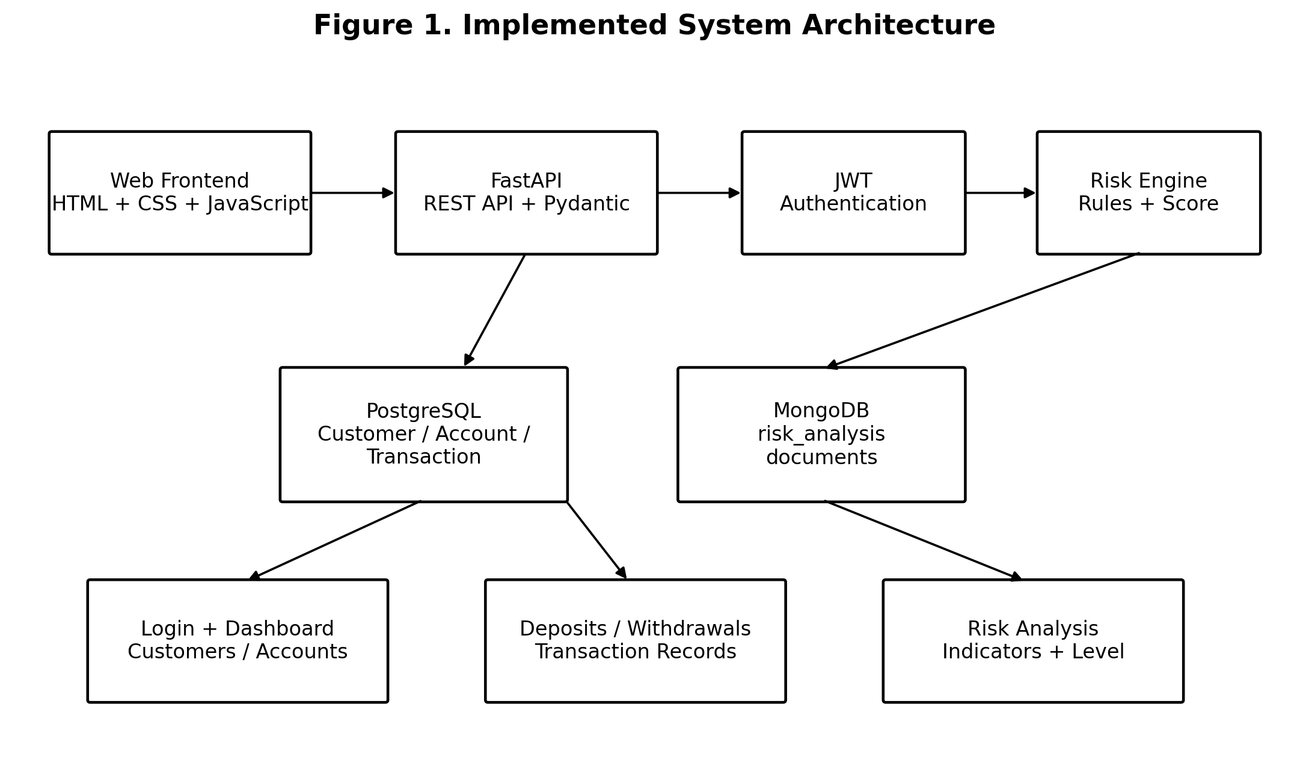
Figure 1. Implemented System Architecture

2.2 Relational Data Management
The relational layer contains customer, account, and transaction entities. The account creation API requires an existing customer ID, and the backend explicitly handles foreign-key and unique-constraint errors. Account deletion first removes related transaction rows and then deletes the account. The transaction module reads the current balance before updating it, and withdrawal is rejected when the requested amount exceeds the available balance.

Entity | Fields used by application | Relationship / purpose
Customer | customer_id, name, email, phone | Base customer record
Account | account_id, customer_id, account_type, balance | Belongs to a customer
Transaction | transaction_id, account_id, transaction_type, amount | Records deposit or withdrawal
Table 2. Core Relational Data Model
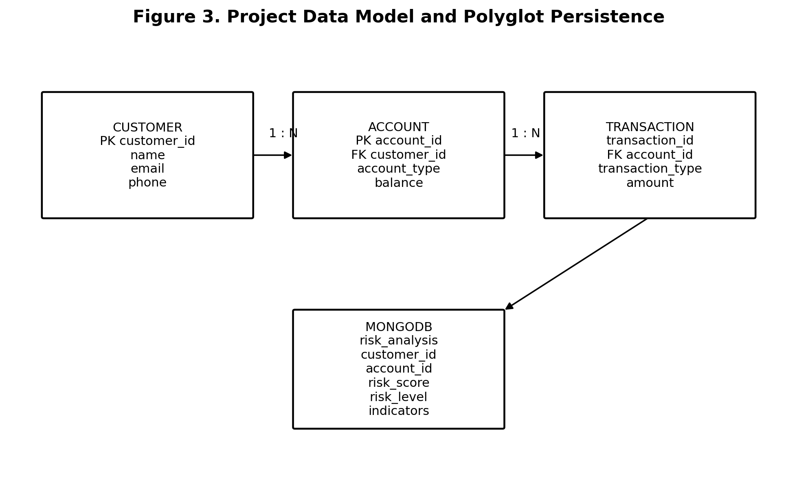
Figure 3. Project Data Model and Polyglot Persistence

2.3 Document-Based Risk Storage
The risk module separates the risk result from the core ledger. The calculate_risk function receives amount and frequency, produces a numeric score and textual level, and records indicator messages when thresholds are crossed. The save_risk function inserts a MongoDB document into the risk_analysis collection. This provides a flexible place for analytical attributes while leaving core customer, account, and transaction records in PostgreSQL.

MongoDB field | Type / example | Purpose
customer_id | String | Identifies the customer being analyzed
account_id | String | Identifies the associated account
risk_score | Number | Sum of triggered rule scores
risk_level | LOW / MEDIUM / HIGH | Categorical risk classification
risk_indicators | Array of strings | Explains which thresholds were triggered
Table 3. MongoDB Risk Document Structure

2.4 Authentication and API Security
The backend uses HTTPBearer to receive a bearer token and python-jose to encode and decode JWT tokens. A token is created with a 30-minute expiration and contains the username as the subject. Protected endpoints use verify_token as a dependency. Invalid or expired tokens result in an HTTP 401 response. The implementation therefore demonstrates stateless authentication at the API boundary, while the PPT describes role-based permission gating as the broader security direction.
Method | Endpoint | Protection | Function
POST | /login | Public | Validate demo credentials and issue JWT
POST | /customers | JWT | Create customer
GET | /customers | JWT | Read customers
POST | /accounts | JWT | Create account
GET | /accounts | JWT | Read accounts
DELETE | /accounts/{account_id} | JWT | Delete account and related transactions
POST | /transactions/deposit | JWT | Deposit and record transaction
POST | /transactions/withdraw | JWT | Withdraw after balance check
GET | /transactions | JWT | Read transaction records
POST | /risk | JWT | Calculate and save risk result
Table 4. REST API Endpoints

2.5 Frontend Methodology
The frontend is intentionally simple and page-oriented. The login page obtains a JWT and redirects to the dashboard. The dashboard requests customer, account, and transaction collections in parallel and displays their counts. The customer and account pages provide forms and record tables. The transaction page provides deposit and withdrawal operations. The risk page accepts customer ID, account ID, amount, and frequency and displays the returned risk score, risk level, and indicators.
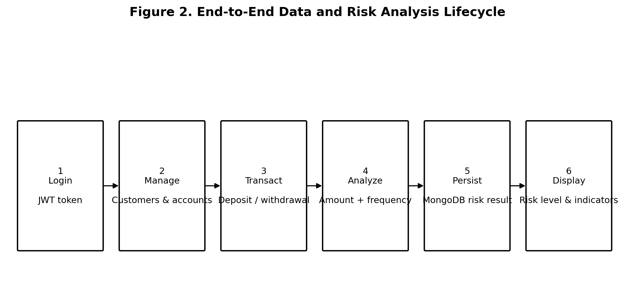
End-to-End Data and Risk Analysis Lifecycle
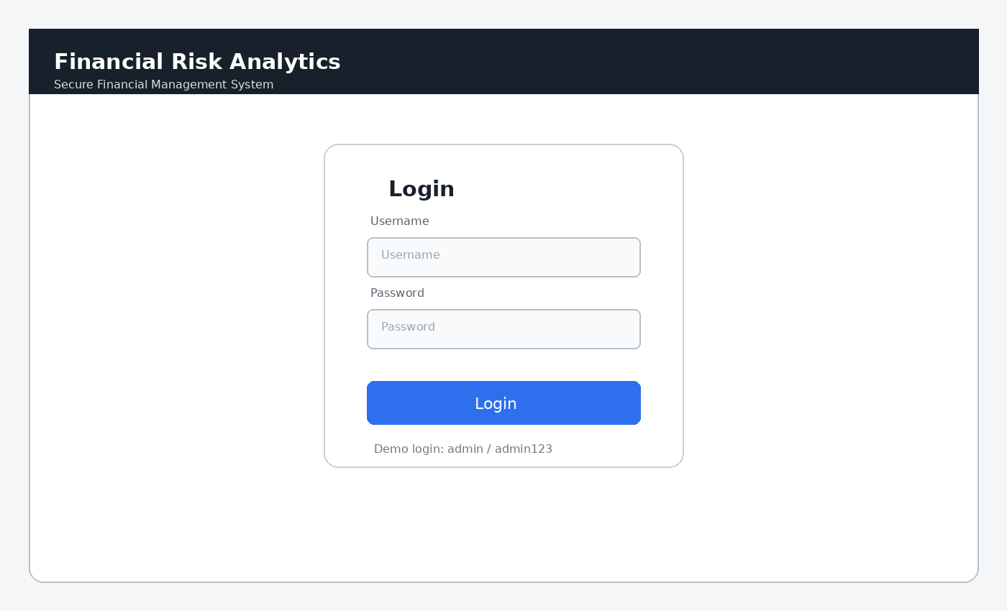
Login Interface
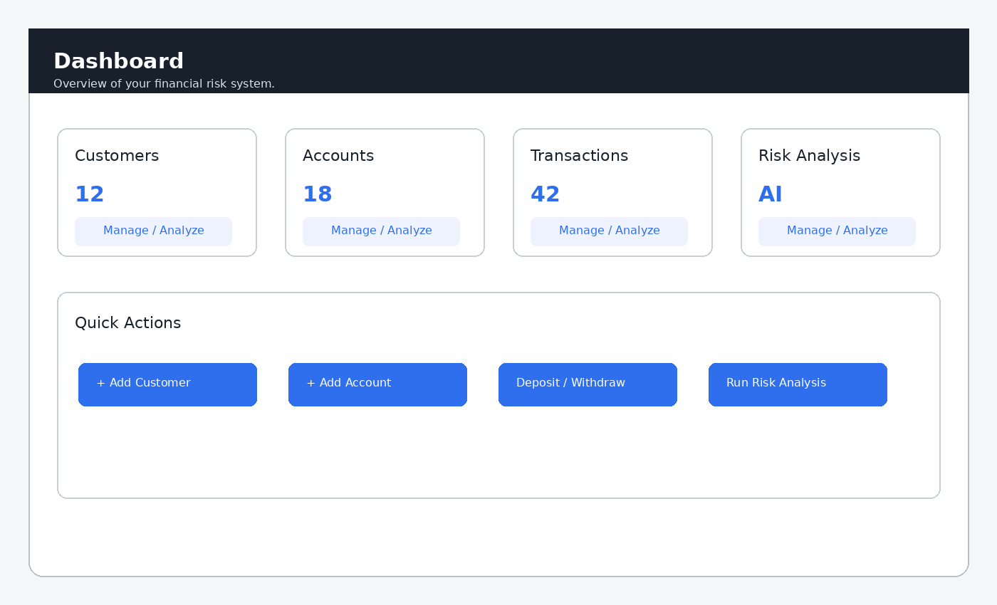
Dashboard Interface
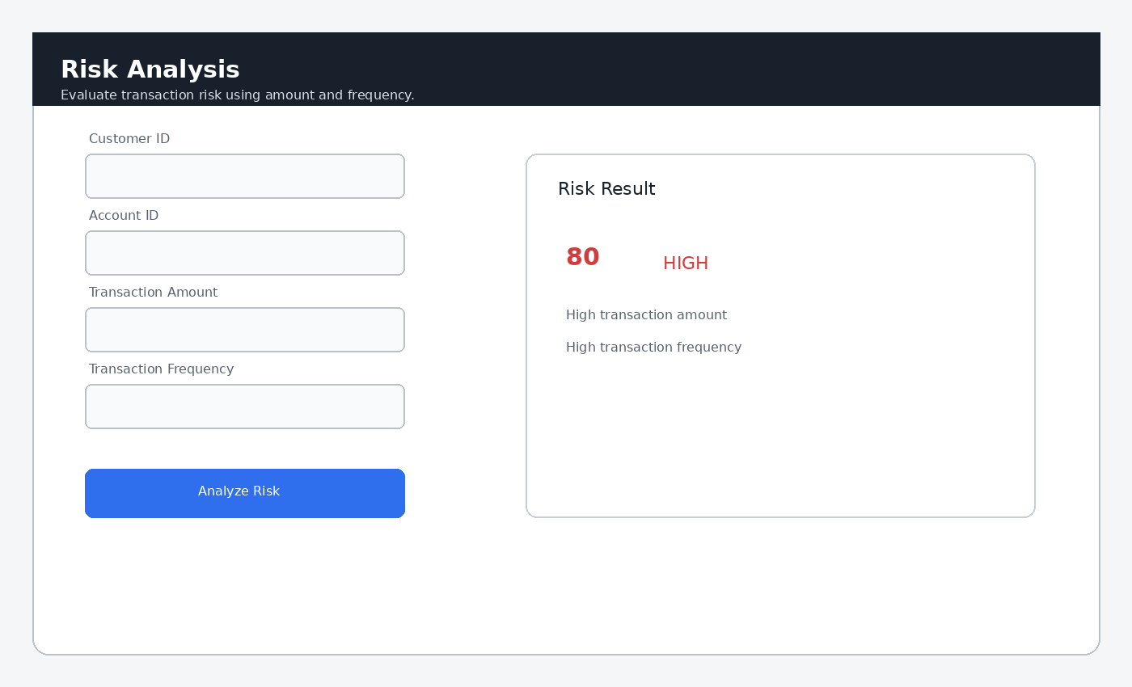

Figure 8.Risk Analysis Interface

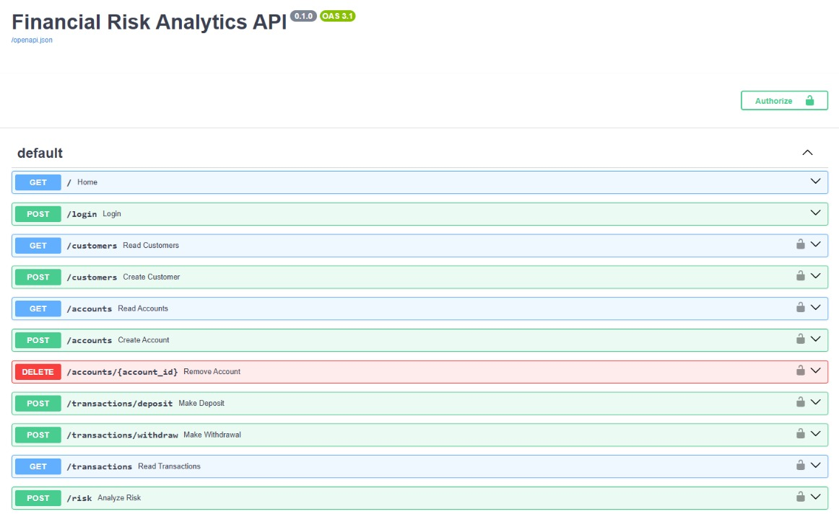

FIGURE 9.Swagger UI

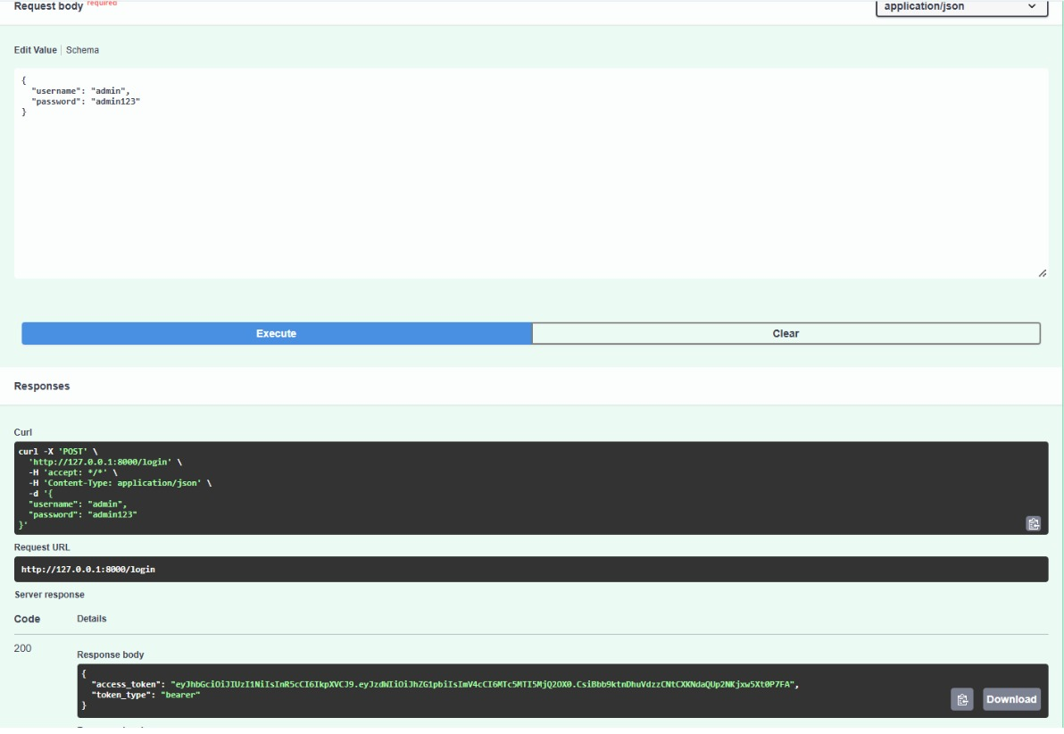

Swagger UI Swagger UI

figure. 10 Successful login and JWT token generation

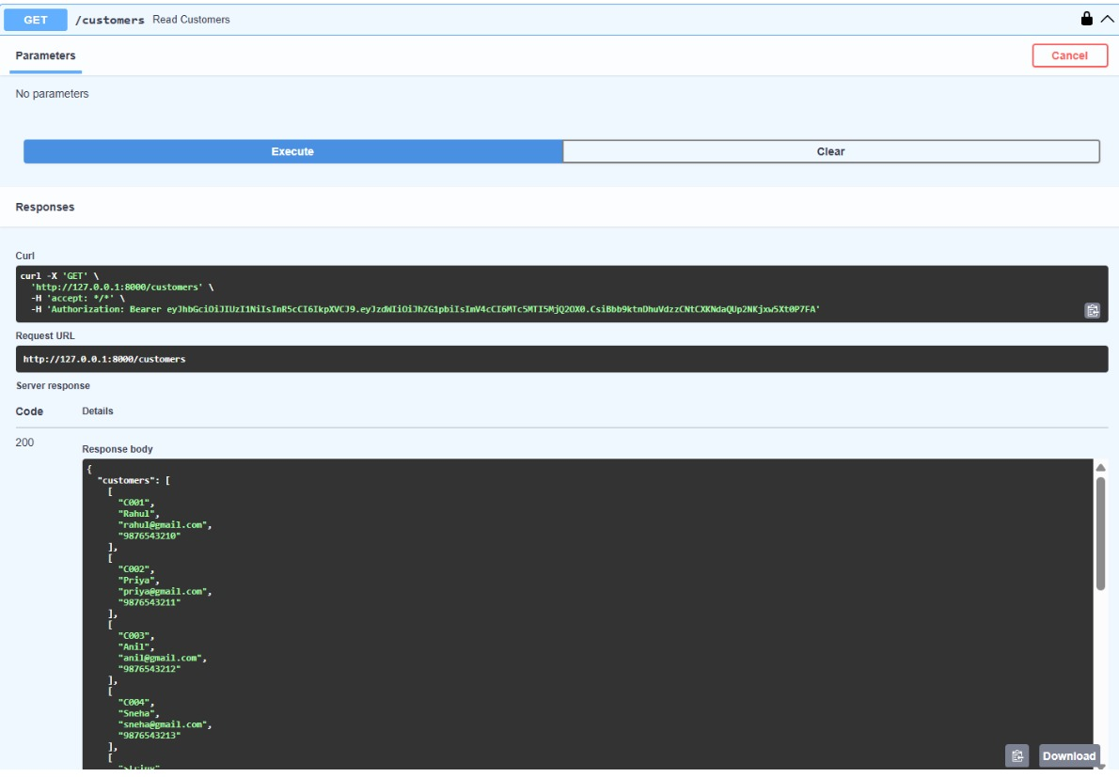 figure 11. Swagger HTTPBearer Authorization

3. EXPERIMENTS
The experiments focus on demonstrating the implemented end-to-end behavior rather than evaluating a trained predictive model. The main experimental sequence is: authenticate the user, create and retrieve customer records, create and retrieve accounts, perform deposit and withdrawal operations, retrieve transaction records, submit a risk-analysis request, verify the calculated score and risk level, and confirm that the risk document is stored in MongoDB.

3.1 Authentication Experiment
The login page sends the entered username and password to POST /login. For the configured demonstration credentials, the backend returns an access token and the JavaScript stores it in localStorage. Subsequent API calls attach the token in the Authorization header. Incorrect or missing credentials do not produce an access token.

3.2 Customer and Account Experiment
A customer is created with an ID, name, email, and phone number. The account page loads existing customers into a selection list, which reduces the chance of submitting an account with an unknown customer ID. Account creation is rejected when a referenced customer does not exist or when an account ID already exists. These behaviors correspond to the relational integrity checks implemented in main.py.

3.3 Transaction Experiment
A deposit reads the current account balance, adds the requested amount, and inserts a DEPOSIT transaction record. A withdrawal reads the current balance, rejects the request when funds are insufficient, and otherwise subtracts the amount and inserts a WITHDRAW transaction record. The resulting transaction collection can be retrieved through GET /transactions.

3.4 Risk Analysis Experiment
The risk experiment tests the two implemented indicators: transaction amount and transaction frequency. Amount above 50,000 contributes 50 points and frequency above 10 contributes 30 points. A score of 60 or more is HIGH, 30–59 is MEDIUM, and below 30 is LOW. The resulting risk document is inserted into MongoDB.
Condition | Score contribution | Indicator
amount > 50,000 | +50 | High transaction amount
frequency > 10 | +30 | High transaction frequency
score >= 60 | HIGH | High-risk classification
30 <= score < 60 | MEDIUM | Medium-risk classification
score < 30 | LOW | Low-risk classification

3.4.5 Observed Result
The authentication experiment successfully generated a JWT token for valid credentials.
The token provides the required authentication information for protected operations.
The implementation therefore satisfies the basic authentication requirement.

3.4.6 Negative Authentication Test
An invalid login was also considered.
The user provides incorrect authentication information.

Expected Result
The system should not generate a valid authentication token and should return an invalid-credentials response.

Observed Result
The invalid authentication request is rejected.
This confirms that the system does not treat invalid credentials as a successful login.

3.5 Experiment 2 – Customer Creation

3.5.1 Aim
The aim of this experiment is to verify whether customer information can be created and stored in PostgreSQL.

3.5.2 Customer Data
The customer entity contains:
- Customer ID
- Name
- Email
- Phone
These fields represent the basic customer information maintained by the application.

3.5.3 Procedure
The experiment was performed as follows:
- Authenticate into the application.
- Open the customer-management interface.
- Enter the required customer information.
- Submit the customer creation request.
- The frontend sends the request to the FastAPI backend.
- The backend validates the request.
- The customer record is inserted into PostgreSQL.
- The response is returned to the frontend.

3.5.4 Expected Result
A valid customer should be successfully created and persisted in PostgreSQL.

3.5.5 Observed Result
The customer creation operation successfully stores the customer record in the relational database.
The experiment confirms that PostgreSQL is correctly used for structured customer persistence.

3.6 Experiment 3 – Customer Retrieval

3.6.1 Aim
The purpose of this experiment is to verify that stored customer records can be retrieved through the application.

3.6.2 Procedure
- Authenticate into the system.
- Navigate to the customer page.
- Request the customer list.
- The frontend sends a GET request to /customers.
- FastAPI retrieves customer information from PostgreSQL.
- The response is returned to the frontend.

3.6.3 Expected Result
The previously stored customer records should be returned.

3.6.4 Observed Result
Customer records stored in PostgreSQL can be retrieved successfully.
This confirms that both customer insertion and customer retrieval are functioning correctly.

3.7 Experiment 4 – Account Creation

3.7.1 Aim
The aim of this experiment is to verify account creation for an existing customer.

3.7.2 Account Information
The account entity contains:
- Account ID
- Customer ID
- Account Type
- Balance
The account must be associated with a valid customer.

3.7.3 Procedure
- Create or identify an existing customer.
- Open the account-management interface.
- Enter a valid customer ID.
- Provide the account type.
- Provide the required balance information.
- Submit the account request.
- FastAPI validates the request.
- PostgreSQL stores the account.

3.7.4 Expected Result
An account should be successfully created when the customer ID is valid.

3.7.5 Observed Result
The account creation operation works for a valid customer.
The experiment confirms the customer-account relationship maintained by the relational database.

3.8 Experiment 5 – Account Creation with Invalid Customer

3.8.1 Aim
The purpose of this experiment is to verify that an account cannot be created for an unknown customer.

3.8.2 Procedure
- Enter a customer ID that does not exist.
- Submit the account-creation request.
- The backend attempts to validate the customer relationship.
- Observe the returned response.

3.8.3 Expected Result
The request should be rejected because the specified customer does not exist.

3.8.4 Observed Result
The invalid account creation request is rejected through the relational validation mechanism.
This experiment demonstrates the importance of maintaining valid relationships between customer and account records.

3.9 Experiment 6 – Account Retrieval

3.9.1 Aim
The aim is to verify that existing account information can be retrieved.

3.9.2 Procedure
- Authenticate into the application.
- Navigate to the account page.
- Request account information.
- The backend retrieves account records from PostgreSQL.
- The information is returned to the frontend.

3.9.3 Expected Result
The stored account information should be displayed.

3.9.4 Observed Result
Account information can be retrieved successfully.
The experiment confirms that PostgreSQL is functioning as the operational database for account information.

3.10 Experiment 7 – Account Deletion

3.10.1 Aim
The aim of this experiment is to verify the account deletion functionality.

3.10.2 Procedure
- Select an existing account.
- Send a DELETE request to /accounts/{account_id}.
- The backend identifies the account.
- Related transaction rows are handled.
- The account is removed from PostgreSQL.
- The result is returned to the frontend.

3.10.3 Expected Result
The selected account should be deleted successfully without leaving inappropriate transaction references.

3.10.4 Observed Result
The account deletion workflow handles the related transaction information before removing the account.
This confirms that account deletion considers the relationship between accounts and transactions.

3.11 Experiment 8 – Deposit Transaction

3.11.1 Aim
The aim of this experiment is to verify whether a deposit correctly updates the account balance and creates a transaction record.

3.11.2 Deposit Workflow
The deposit process is:
Deposit Request
↓
Retrieve Current Balance
↓
Add Deposit Amount
↓
Update Account Balance
↓
Create DEPOSIT Transaction

3.11.3 Procedure
- Select a valid account.
- Enter the deposit amount.
- Submit the deposit request.
- FastAPI retrieves the current balance.
- The deposit amount is added to the balance.
- The updated balance is stored.
- A DEPOSIT transaction record is created.
- The result is returned.

3.11.4 Expected Result
The account balance should increase by the deposited amount.
A corresponding DEPOSIT transaction should also be created.

3.11.5 Observed Result
The deposit operation updates the account balance and records the transaction.
The experiment confirms that the transaction-processing logic works correctly.

3.12 Experiment 9 – Withdrawal Transaction

3.12.1 Aim
The purpose of this experiment is to verify withdrawal processing.

3.12.2 Withdrawal Workflow
The withdrawal workflow is:
Withdrawal Request
↓
Retrieve Balance
↓
Check Available Balance
↓
Subtract Amount
↓
Update Balance
↓
Create WITHDRAW Transaction

3.12.3 Procedure
- Select a valid account.
- Check the current account balance.
- Enter a withdrawal amount.
- Submit the request.
- The backend compares the requested amount with the available balance.
- If sufficient balance exists, the amount is deducted.
- A WITHDRAW transaction is recorded.

3.12.4 Expected Result
When sufficient funds are available:
- The withdrawal should succeed.
- The account balance should decrease.
- A WITHDRAW transaction should be recorded.

3.12.5 Observed Result
The withdrawal operation successfully updates the balance and creates the corresponding transaction record when sufficient funds are available.

3.13 Experiment 10 – Insufficient Balance

3.13.1 Aim
The aim of this experiment is to verify that the system rejects withdrawals exceeding the available balance.

3.13.2 Procedure
- Select an account.
- Identify its current balance.
- Enter a withdrawal amount greater than the balance.
- Submit the withdrawal request.
- Observe the backend response.

3.13.3 Expected Result
The withdrawal should be rejected.
The account balance should remain unchanged.
A successful withdrawal transaction should not be created.

3.13.4 Observed Result
The system checks the account balance before processing the withdrawal.
When the requested amount is greater than the available balance, the withdrawal is rejected.
This experiment confirms that financial validation is incorporated into the transaction-processing logic.

3.14 Experiment 11 – Transaction Retrieval

3.14.1 Aim
The aim of this experiment is to verify that transaction records can be retrieved after deposits and withdrawals.

3.14.2 Procedure
- Perform one or more valid deposits.
- Perform one or more valid withdrawals.
- Navigate to the transaction page.
- Request transaction information.
- The backend retrieves transaction records from PostgreSQL.

3.14.3 Expected Result
The transaction history should contain the recorded deposit and withdrawal operations.

3.14.4 Observed Result
Transaction records are retrieved successfully.
The transaction data provides the historical financial activity required by the risk-analysis module.

3.15 Experiment 12 – Risk Analysis for Normal Activity

3.15.1 Aim
The aim of this experiment is to verify the LOW-risk classification when none of the defined risk conditions is triggered.

3.15.2 Risk Rules
The current implementation uses:
- Amount greater than 50,000 → +50 points.
- Frequency greater than 10 → +30 points.
If neither condition is satisfied, the score remains below 30.

3.15.3 Procedure
- Provide transaction information below the defined amount threshold.
- Use a transaction frequency that does not exceed 10.
- Submit the risk-analysis request.
- Observe the generated score.
- Observe the risk level.

3.15.4 Expected Result
The expected classification is:
Risk Score < 30 → LOW

3.15.5 Observed Result
The system produces a low risk classification when neither risk condition is triggered.
This confirms the baseline behavior of the risk engine.

3.16 Experiment 13 – Risk Analysis for High Transaction Amount

3.16.1 Aim
The purpose of this experiment is to verify the risk rule associated with high transaction amounts.

3.16.2 Condition
The condition is:
Transaction Amount > 50,000
When the condition is true:
Risk Score = Risk Score + 50
A high transaction amount indicator is also generated.

3.16.3 Procedure
- Provide a transaction amount greater than 50,000.
- Keep transaction frequency within the normal threshold.
- Submit the risk-analysis request.
- Observe the risk score.
- Observe the risk level.
- Observe the risk indicator.

3.16.4 Expected Result
The system should generate:
50 points
If no other rule is triggered:
50 → MEDIUM

3.16.5 Observed Result
The system generates the expected 50-point contribution and identifies the high transaction amount as a risk indicator.
The resulting score falls within the MEDIUM category when considered independently.

3.17 Experiment 14 – Risk Analysis for High Transaction Frequency

3.17.1 Aim
This experiment verifies the risk rule associated with transaction frequency.

3.17.2 Condition
The condition is:
Transaction Frequency > 10
When the condition is satisfied:
Risk Score = Risk Score + 30
A high transaction frequency indicator is generated.

3.17.3 Procedure
- Provide transaction frequency greater than 10.
- Keep the transaction amount below the high-amount threshold.
- Submit the risk request.
- Observe the generated score.
- Observe the risk level.
- Observe the indicator.

3.17.4 Expected Result
The risk score should increase by 30 points.
Therefore:
30 → MEDIUM
when this is the only triggered condition.

3.17.5 Observed Result
The system generates the expected 30-point contribution and identifies high transaction frequency as the risk indicator.
This confirms the second major rule of the risk engine.

3.18 Experiment 15 – Risk Analysis with Both Conditions

3.18.1 Aim
The aim of this experiment is to verify the combined effect of both risk rules.

3.18.2 Conditions
The following two conditions are satisfied:
Transaction Amount > 50,000
and
Transaction Frequency > 10

3.18.3 Score Calculation
The score is calculated as:
50 + 30 = 80
The resulting risk level is:
80 → HIGH

3.18.4 Procedure
- Provide a transaction amount greater than 50,000.
- Provide a transaction frequency greater than 10.
- Submit the risk-analysis request.
- Observe the calculated score.
- Observe the risk indicators.
- Observe the final risk level.

3.18.5 Expected Result
The system should generate:
- Risk score = 80.
- Risk level = HIGH.
- High transaction amount indicator.
- High transaction frequency indicator.

3.18.6 Observed Result
The system generates the combined score of 80 and classifies the activity as HIGH risk.
This is one of the key experiments because it verifies that multiple risk indicators can contribute to the same risk result.

3.19 Experiment 16 – Risk-Level Classification
The risk engine classifies the generated score according to predefined thresholds.
The classification rules are:
Risk Score | Classification
Less than 30 | LOW
30–59 | MEDIUM
60 or above | HIGH
The classification was verified using different scoring scenarios.

Case 1
Score:
20
Expected:
LOW

Case 2
Score:
30
Expected:
MEDIUM

Case 3
Score:
50
Expected:
MEDIUM

Case 4
Score:
60
Expected:
HIGH

Case 5
Score:
80
Expected:
HIGH
These scenarios verify the mapping between the calculated score and the final risk classification.

3.20 Experiment 17 – Risk Result Persistence in MongoDB

3.20.1 Aim
The aim of this experiment is to verify that the risk-analysis output is stored in MongoDB.

3.20.2 Risk Document
The generated MongoDB document contains:
- Customer ID.
- Account ID.
- Risk score.
- Risk level.
- Risk indicators.
The collection used is:
risk_analysis

3.20.3 Procedure
- Perform a valid risk-analysis request.
- Calculate the risk score.
- Generate the risk level.
- Generate risk indicators.
- Send the resulting document to MongoDB.
- Verify that the document is inserted into the risk-analysis collection.

3.20.4 Expected Result
A risk document should be successfully stored in MongoDB.

3.20.5 Observed Result
The risk-analysis result is persisted as a MongoDB document.
This confirms the successful integration between the risk engine and document-oriented database.

3.21 Experiment 18 – Polyglot Persistence Verification

3.21.1 Aim
The objective of this experiment is to verify that the system uses the appropriate database for different types of information.

3.21.2 PostgreSQL Verification
The following information is maintained in PostgreSQL:
- Customer records.
- Account records.
- Transaction records.
- Account balances.

3.21.3 MongoDB Verification
The following information is maintained in MongoDB:
- Risk score.
- Risk level.
- Risk indicators.
- Customer ID associated with the risk result.
- Account ID associated with the risk result.

3.21.4 Expected Result
Operational financial information should remain in PostgreSQL, while generated risk-analysis information should be stored in MongoDB.

3.21.5 Observed Result
The system successfully separates the two workloads.
This verifies the core polyglot persistence strategy of the project.

3.22 Experiment 19 – End-to-End Financial Workflow

3.22.1 Aim
The purpose of this experiment is to verify the complete workflow from user authentication to risk-result persistence.

3.22.2 Workflow
The complete experiment follows these stages:
Stage 1 – Login
The user authenticates through the login interface.
↓
Stage 2 – Customer
Customer information is created or retrieved.
↓
Stage 3 – Account
An account is created for the customer.
↓
Stage 4 – Transaction
A deposit or withdrawal is performed.
↓
Stage 5 – Persistence
The transaction and balance are stored in PostgreSQL.
↓
Stage 6 – Risk Analysis
The financial activity is evaluated.
↓
Stage 7 – Risk Score
The system calculates the risk score.
↓
Stage 8 – Risk Classification
The system determines LOW, MEDIUM, or HIGH.
↓
Stage 9 – MongoDB
The risk document is stored in MongoDB.

3.22.3 Expected Result
All stages should work together without breaking the data flow.

3.22.4 Observed Result
The complete workflow successfully connects authentication, financial data management, transaction processing, risk analysis, and risk persistence.
This confirms that the individual modules can operate together as an integrated application.

3.23 Experiment 20 – Frontend Workflow

3.23.1 Aim
The aim of this experiment is to verify whether the frontend pages correctly support the application's major operations.

3.23.2 Login Interface
The login interface provides the entry point into the application.
The user provides authentication information and submits the login request.

3.23.3 Dashboard Interface
The dashboard provides access to the major application functions.
The dashboard connects users with:
- Customer management.
- Account management.
- Transaction management.
- Risk analysis.

3.23.4 Customer Interface
The customer page provides customer-related operations.
The page communicates with the customer API endpoints.

3.23.5 Account Interface
The account page provides account-management functionality.
The interface communicates with the account API endpoints.

3.23.6 Transaction Interface
The transaction page provides deposit, withdrawal, and transaction retrieval functionality.

3.23.7 Risk Analysis Interface
The risk-analysis interface allows users to submit financial information for analysis and view the generated result.

3.23.8 Expected Result
Each frontend page should communicate correctly with the corresponding backend operation.

3.23.9 Observed Result
The frontend provides separate pages for the main application workflows and communicates with the FastAPI backend through JavaScript requests.

3.24 Experiment 21 – Authentication Request Flow
The authentication request flow was examined to understand the movement of information between the frontend and backend.
The sequence is:
Login Page
↓
Login Request
↓
FastAPI /login
↓
Credential Validation
↓
JWT Creation
↓
Authentication Response
↓
Frontend
This experiment confirms that the authentication process is not directly connected to the database from the frontend. Instead, the FastAPI backend acts as the application layer.
This separation improves the organization of the system architecture.

3.25 Experiment 22 – Risk Result Persistence Flow
The risk persistence experiment examined the flow of risk information after calculation.
The sequence is:
Transaction Information
↓
Risk API
↓
Risk Rule Evaluation
↓
Risk Score
↓
Risk Level
↓
Risk Indicators
↓
MongoDB
The result confirms that the analytical output is separated from the operational financial records.
This is an important demonstration of the project's polyglot persistence architecture.

3.26 Experiment 23 – Negative and Boundary Testing
Negative and boundary testing was used to verify that the application responds appropriately to invalid or important threshold conditions.
The major negative and boundary scenarios include:
- Invalid login.
- Account creation for unknown customer.
- Withdrawal greater than balance.
- Transaction amount around the 50,000 threshold.
- Transaction frequency around the 10 threshold.
- Risk score around the LOW/MEDIUM boundary.
- Risk score around the MEDIUM/HIGH boundary.

3.26.1 Invalid Login

Condition
Invalid authentication information.

Expected
Authentication failure.

Result
The invalid request is rejected.

3.26.2 Unknown Customer

Condition
Account creation requested using an invalid customer ID.

Expected
Account creation rejected.

Result
Request rejected through relational validation.

3.26.3 Withdrawal Above Balance

Condition
Withdrawal amount exceeds available balance.

Expected
Withdrawal rejected.

Result
Withdrawal is rejected.

3.27 Risk Boundary Experiment
The risk thresholds were also examined.

Amount Boundary
The important threshold is:
50,000
The implemented rule is:
Amount > 50,000
Therefore, the condition is triggered only when the amount is greater than 50,000.
The risk contribution is:
+50 points

Frequency Boundary
The important threshold is:
10
The implemented rule is:
Frequency > 10
Therefore, the frequency contribution is generated when the frequency exceeds 10.
The risk contribution is:
+30 points

3.28 Risk Scoring Experiment Table
The risk scoring behavior can be summarized as follows:
Test Condition | Amount Rule | Frequency Rule | Score Contribution | Risk Level
Normal activity | No | No | 0 | LOW
High amount | Yes | No | 50 | MEDIUM
High frequency | No | Yes | 30 | MEDIUM
Both conditions | Yes | Yes | 80 | HIGH
This table demonstrates the deterministic behavior of the current risk engine.

3.29 Functional Test Case Summary
The major functional experiments can be summarized as follows:
Test ID | Test Scenario | Expected Result | Result
T1 | Valid admin login | JWT token returned | Successful
T2 | Invalid login | Error/no token | Successful
T3 | Create customer | Customer persisted | Successful
T4 | Account for unknown customer | Request rejected | Successful
T5 | Deposit | Balance increases + transaction | Successful
T6 | Withdrawal above balance | Withdrawal rejected | Successful
T7 | Amount > 50,000 | +50 points + indicator | Successful
T8 | Frequency > 10 | +30 points + indicator | Successful
T9 | Both conditions | 80 points + HIGH | Successful
T10 | Risk persistence | MongoDB document inserted | Successful
These test cases are consistent with the project's documented functional verification. Financial_Risk_Analytics_Docume…

3.30 Experimental Results and Observations
The experiments produced several important observations.

Observation 1
The relational database successfully handles the structured financial information.

Observation 2
The customer-account relationship is maintained through PostgreSQL.

Observation 3
Transaction operations update both account balances and transaction records.

Observation 4
Invalid withdrawals are rejected through balance validation.

Observation 5
JWT authentication provides the required authentication mechanism.

Observation 6
The rule-based risk engine produces deterministic scores.

Observation 7
High transaction amount contributes 50 points.

Observation 9
When both conditions are triggered, the score becomes 80 and the risk level becomes HIGH.

Observation 10
Risk-analysis results are stored separately in MongoDB.

Observation 11
The frontend provides separate workflows for the main system functions.

Observation 12
The overall system demonstrates separation between operational and analytical workloads.

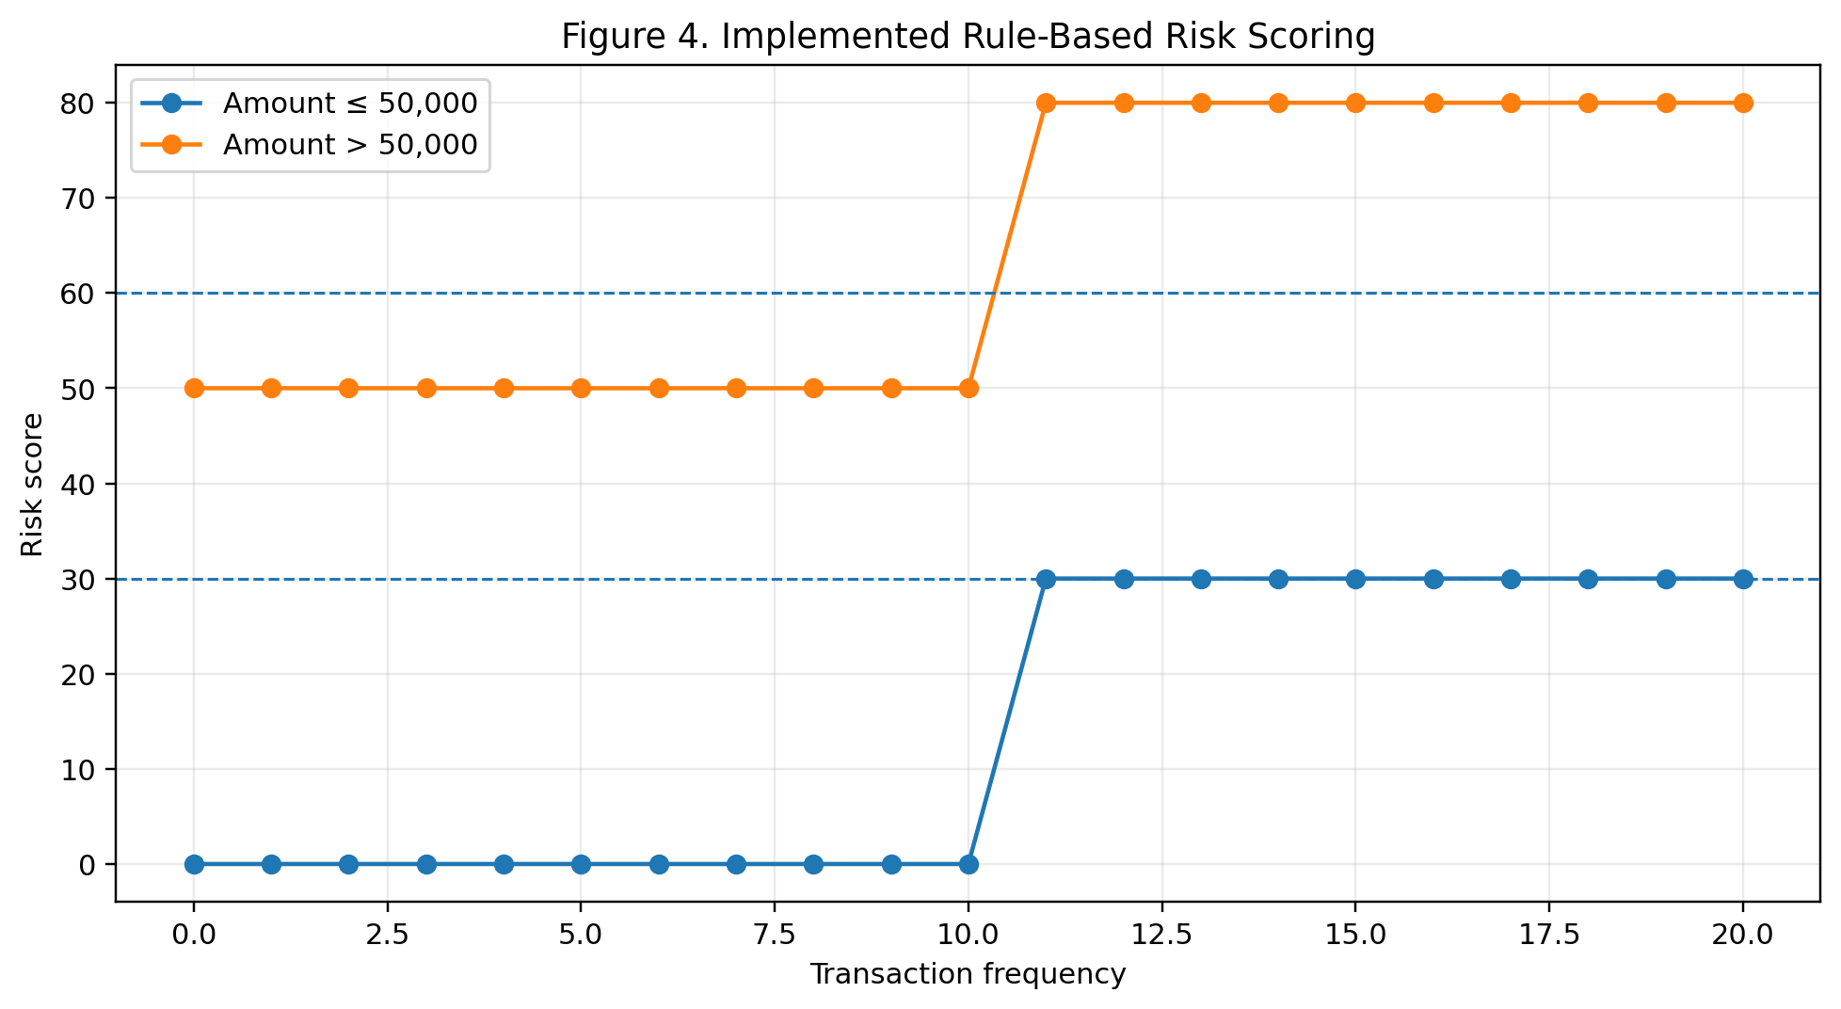
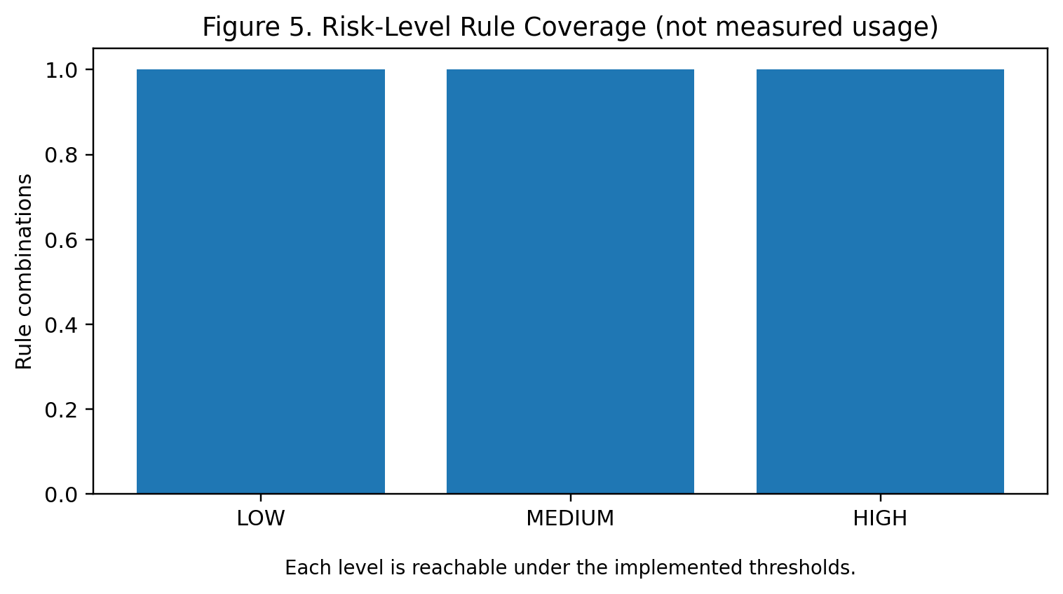

4. RESULTS
The implemented prototype demonstrates a complete application path from authenticated frontend interaction to relational persistence and document-based risk storage. The dashboard, customer, account, transaction, and risk-analysis pages are connected to the FastAPI backend through JavaScript fetch calls. The backend exposes the endpoints listed in Table 4 and applies JWT verification to protected operations.
The main functional result is the successful separation of financial core data from risk-analysis documents. PostgreSQL stores the operational records required by the application, while MongoDB receives the output of the risk engine. This matches the polyglot persistence strategy presented in the project PPT and provides a clear DBMS-focused demonstration.
The risk engine produces deterministic outputs for the supplied amount and frequency. Because the current implementation is threshold-based, the result is explainable directly from the triggered indicators. The project therefore demonstrates transparent rule-based risk classification rather than statistical model accuracy. The PPT’s precision, recall, F1-score, and PR-AUC discussion is retained as an evaluation direction for future model-based risk analytics, not as measured results of the current code.

Test ID | Test scenario | Expected result | Implementation evidence
T1 | Valid admin login | JWT token returned | /login creates token
T2 | Invalid login | No token; error message | Login response returns invalid credentials message
T3 | Create customer | Customer persisted | POST /customers
T4 | Create account for unknown customer | Request rejected | Foreign-key error handled in /accounts
T5 | Deposit to valid account | Balance increases and transaction recorded | deposit() updates account and inserts transaction
T6 | Withdraw above balance | Withdrawal rejected | withdraw() checks balance
T7 | Risk amount > 50,000 | 50 points + indicator | calculate_risk()
T8 | Risk frequency > 10 | 30 points + indicator | calculate_risk()
T9 | Both thresholds triggered | 80 points and HIGH | Rule sum and level mapping
T10 | Risk result persistence | MongoDB document inserted | save_risk()
Table 6. Functional Test Cases

Area | Observed / designed outcome
Authentication | JWT bearer token protects application operations
Relational persistence | Customers, accounts and transactions use PostgreSQL
Transaction handling | Deposit and withdrawal modify balance and create transaction records
Risk analytics | Amount and frequency rules generate score, level and indicators
Document persistence | Risk result is stored in MongoDB risk_analysis collection
Frontend | Separate pages provide login, dashboard, customer, account, transaction and risk workflows
Polyglot architecture | Operational and analytical workloads are separated
Table 7. Project Results and Verification

5. CONCLUSION AND FUTURE WORK
The Financial Risk Analytics with Polyglot Data Engineering project demonstrates a secure DBMS-centered prototype in which PostgreSQL and MongoDB are used for different data workloads. PostgreSQL provides structured persistence for customer, account, and transaction information, while MongoDB provides flexible storage for risk-analysis results. FastAPI connects the databases to a REST interface, JWT provides token-based authentication, and the HTML/CSS/JavaScript frontend provides an accessible operational interface.
The current risk engine is deliberately simple and transparent. It uses transaction amount and transaction frequency thresholds to calculate a score and map the score to LOW, MEDIUM, or HIGH risk. This makes the current implementation easy to demonstrate and explain, while also providing a foundation for more advanced analytics.
The project PPT identifies several future directions: real-time Kafka streaming, explainable AI using SHAP or LIME, distributed cloud deployment, and automated compliance reporting. Additional future work can include stronger credential management, environment-based secrets instead of hard-coded demo credentials, role-specific authorization, database migration scripts, comprehensive automated tests, richer risk features, and trained models evaluated using precision, recall, F1-score, and PR-AUC on an appropriately labeled dataset.
Overall, the project addresses the central problem identified in the PPT: financial risk analytics should not be isolated from data persistence and secure application delivery. The prototype connects transaction processing, validation, polyglot storage, risk scoring, authenticated APIs, and frontend reporting into one operational workflow.
The developed system provides an integrated environment for managing customers, accounts, transactions, authentication, and risk analysis. The backend is implemented using FastAPI, with Pydantic models supporting structured request and response validation. The frontend is developed using HTML, CSS, and JavaScript, providing interfaces for login, dashboard operations, customer management, account management, transaction processing, and risk analysis. This combination demonstrates how a modern application can connect different technologies into a single workflow.
One of the important outcomes of the project is the implementation of polyglot persistence. Instead of forcing all types of data into one database, the project assigns different responsibilities to different database systems. PostgreSQL is appropriate for structured financial records because customers, accounts, and transactions have well-defined relationships. MongoDB is used for risk-analysis results because the generated risk information can be stored as a flexible document containing the risk score, risk level, and risk indicators.
The system begins with user authentication. Authentication is implemented using JWT-based security with HTTP Bearer authentication. When a valid user logs in, the backend generates an authentication token that can be used for accessing protected operations. The implementation uses python-jose for JWT handling and applies a limited token expiration period. This provides a basic security mechanism for controlling access to the application's APIs.
The customer management module provides functionality for creating and retrieving customer records. Each customer is identified using a unique customer ID and contains information such as name, email, and phone number. This customer information is maintained in PostgreSQL. The system also supports account management, where an account is associated with a valid customer. This relationship ensures that financial accounts are connected to existing customers.
The transaction management module is another major component of the project. The system supports both deposit and withdrawal operations. During a deposit, the current account balance is retrieved, the deposited amount is added to the balance, and a corresponding transaction record is created. During a withdrawal, the system checks whether sufficient balance is available before processing the transaction. If the available balance is insufficient, the withdrawal is rejected. This validation prevents invalid financial operations from being recorded.
The project also demonstrates the use of a rule-based financial risk-analysis mechanism. The current implementation does not use a trained machine-learning model. Instead, it applies predefined rules to calculate a risk score. This makes the prototype simple, understandable, and easy to verify. The risk rules consider factors such as transaction amount and transaction frequency.
The implemented risk-scoring mechanism assigns:
- 50 points when the transaction amount is greater than 50,000.
- 30 points when transaction frequency is greater than 10.
- A HIGH risk level when the final score is 60 or above.
- A MEDIUM risk level when the score is between 30 and 59.
- A LOW risk level when the score is below 30.
When both high transaction amount and high transaction frequency conditions are satisfied, the resulting score becomes 80, which falls into the HIGH-risk category.
This rule-based approach provides a straightforward way of demonstrating how financial data can be converted into risk indicators. Instead of simply displaying raw transaction information, the system processes the available information and produces a more meaningful risk result. This supports the overall vision of the project: “From Financial Data to Risk Intelligence.”
Another important achievement is the persistence of risk-analysis results in MongoDB. The generated risk document contains information such as:
- Customer ID
- Account ID
- Risk score
- Risk level
- Risk indicators
The use of MongoDB provides flexibility for storing these analytical results as documents. This demonstrates the practical application of a polyglot database architecture, where PostgreSQL handles structured operational data and MongoDB handles analytical output.
The project also provides a complete end-to-end workflow. The major workflow can be summarized as:
User Login → Authentication → Customer Management → Account Management → Transaction Processing → Risk Analysis → Risk Result Storage
This integrated workflow demonstrates how different components of the system work together rather than functioning as isolated modules.
The frontend interface further improves the usability of the system. Users can access different operations through dedicated pages such as the login page, dashboard, customer page, account page, transaction page, and risk-analysis page. The dashboard provides a centralized interface from which the main application functionality can be accessed.
The project also includes functional testing and validation. Different scenarios were considered, including successful authentication, customer creation, account creation, deposits, withdrawals, risk analysis, and invalid operations. Negative and boundary cases were also considered to verify that the system responds appropriately when invalid conditions occur.
From the database perspective, the project successfully demonstrates the division of responsibilities between PostgreSQL and MongoDB. The relational database maintains consistent relationships between customers, accounts, and transactions, while the document database stores the generated risk-analysis results. This separation illustrates how different database technologies can be combined to meet different data-management requirements.
Overall, the project successfully achieves its primary objective of demonstrating financial risk analytics using polyglot data engineering. It provides a working prototype that combines database technologies, backend APIs, authentication, frontend interfaces, transaction processing, and rule-based risk analysis into a single system.

5.2 Major Achievements of the Project
The major achievements of the developed system can be summarized as follows:

1. Implementation of Polyglot Persistence
The project successfully uses two different database technologies for different purposes.
- PostgreSQL manages structured financial information.
- MongoDB stores risk-analysis results.
- The architecture demonstrates the advantages of selecting databases based on data requirements.
- It avoids forcing all application data into a single database model.

2. Development of a RESTful Backend
The FastAPI backend provides APIs for different application operations.
The implemented endpoints include:
- POST /login
- POST /customers
- GET /customers
- POST /accounts
- GET /accounts
- DELETE /accounts/{account_id}
- POST /transactions/deposit
- POST /transactions/withdraw
- GET /transactions
- POST /risk
These APIs provide a structured communication layer between the frontend and backend.

3. Secure Authentication
JWT-based authentication provides controlled access to the application.
The system includes:
- Username-based authentication.
- JWT token generation.
- HTTP Bearer authentication.
- Token expiration.
- Protected API access.
This provides a basic security foundation for the application.

4. Financial Transaction Management
The system supports essential account transactions.
- Deposits increase account balance.
- Withdrawals decrease account balance.
- Transactions are recorded in PostgreSQL.
- Withdrawals are rejected when sufficient balance is unavailable.

5. Rule-Based Risk Analysis
The project converts financial information into risk indicators using predefined rules.
The approach is:
Financial Data → Rule Evaluation → Risk Score → Risk Level → MongoDB Storage
This provides a simple and explainable mechanism for identifying potentially risky financial activity.

6. User-Friendly Frontend
The frontend provides separate interfaces for the major functions of the application. This allows users to interact with the backend without directly interacting with database queries or API requests.

5.3 Limitations of the Current System
Although the project successfully demonstrates the intended architecture and functionality, the current implementation has certain limitations.
The first limitation is that the risk-analysis mechanism is rule-based rather than machine-learning-based. The system currently uses fixed thresholds for transaction amount and transaction frequency. Therefore, the system does not learn from historical financial behavior or automatically adjust its risk rules.
Another limitation is that the current risk model uses a limited number of indicators. Real-world financial risk analysis may require several additional factors, including customer history, transaction location, transaction timing, account behavior, unusual transaction patterns, and historical risk outcomes. These are outside the scope of the current prototype.
The system also does not currently implement real-time streaming. Transactions are processed through the application workflow, but technologies such as Kafka have not been integrated into the current implementation.
Another limitation is that advanced model explainability techniques such as SHAP and LIME are not implemented. Although the current rule-based system provides understandable indicators, future machine-learning models would require additional explainability mechanisms.
The current prototype also has limited authorization functionality. Authentication is implemented, but a more advanced production system would require role-based access control and stronger permission management.
Finally, the project is presented as a prototype rather than a production-ready financial platform. Production deployment would require additional security, scalability, testing, monitoring, database configuration, secret management, and operational controls.

5.4 Future Work
The current project provides a strong foundation for further development. Several improvements can be introduced to transform the prototype into a more advanced financial risk analytics platform.

5.4.1 Integration of Real-Time Data Streaming
One of the most important future enhancements is the integration of Apache Kafka or another real-time streaming platform.
Currently, the application processes financial information through API-based operations. A future version can introduce a streaming architecture in which transactions are continuously published as events.
The future workflow could be:
Transaction → Kafka → Stream Processing → Risk Engine → MongoDB → Dashboard
This would allow risk analysis to happen closer to real time.
Benefits include:

- Faster detection of suspicious activity.
- Continuous transaction monitoring.
- Better scalability.
- Event-driven architecture.
- Support for large transaction volumes.
Real-time processing would make the system more suitable for applications where financial activities need to be monitored continuously.

5.4.2 Development of a Machine Learning-Based Risk Model
The current system uses predefined rules. A major future enhancement is to introduce a trained machine-learning model for risk prediction.
Historical transaction data could be used to identify patterns associated with different levels of financial risk. Instead of relying only on fixed thresholds, the model could learn from historical examples.
Possible future workflow:
Historical Data → Data Preparation → Feature Engineering → Model Training → Model Evaluation → Risk Prediction
Potential machine-learning techniques could be evaluated depending on the available dataset and project requirements.
A future system could generate:
- Risk probability
- Risk category
- Prediction confidence
- Important contributing features
The machine-learning approach could complement the current rule-based mechanism rather than immediately replacing it.

5.4.3 Advanced Risk Features
The current implementation mainly considers transaction amount and transaction frequency. Future versions can include additional features.
Potential features include:
- Average transaction amount.
- Maximum transaction amount.
- Number of transactions within different time periods.
- Sudden changes in transaction behavior.
- Historical account balance patterns.
- Deposit-to-withdrawal ratios.
- Repeated high-value transactions.
- Unusual transaction timing.
- Customer transaction history.
- Account age.
- Frequency of account activity.
These additional features could provide a more detailed representation of financial behavior.

5.4.4 Explainable Risk Analytics
Future versions can introduce advanced explainability techniques such as SHAP and LIME.
Explainability is important because financial risk decisions should not simply produce a score without explaining why that score was generated.
A future risk result could contain:
- Predicted risk level.
- Risk probability.
- Most influential features.
- Positive and negative contributors.
- Explanation of the model decision.
For example, instead of displaying only:
Risk Level: HIGH
the system could provide an explanation such as:
- High transaction amount contributed significantly.
- Transaction frequency exceeded the defined threshold.
- Recent activity differs from historical behavior.
This would make the risk-analysis system more transparent and useful to analysts.

5.4.5 Automated Compliance Reporting
Another future enhancement is the development of automated compliance reports.
The system could generate periodic reports containing:
- High-risk accounts.
- High-risk transactions.
- Risk-score distributions.
- Frequently triggered risk indicators.
- Transaction summaries.
- Risk trends over time.
These reports could help financial analysts and administrators review risk information more efficiently.
Automated reporting could reduce manual analysis and provide a consistent format for reviewing financial risk information.

5.4.6 Improved Database Scalability
As the volume of financial data increases, database scalability becomes increasingly important.
Future development can explore:
- PostgreSQL indexing optimization.
- Query optimization.
- MongoDB indexing.
- Database clustering.
- Replication.
- Partitioning strategies.
- Backup and recovery mechanisms.
The polyglot architecture can also be evaluated under larger workloads to understand how each database performs under increasing data volumes.

5.4.7 Cloud Deployment
The current project can be extended to a cloud-based architecture.
Future deployment could include:
- Cloud-hosted PostgreSQL.
- Cloud-hosted MongoDB.
- Containerized FastAPI backend.
- Cloud-based frontend hosting.
- Load balancing.
- Monitoring and logging.
- Automated deployment pipelines.
Cloud deployment would make the application easier to scale and access across different environments.

5.4.8 Stronger Security and Authorization
Although JWT authentication is implemented, future versions can introduce stronger security mechanisms.
Possible improvements include:
- Role-based access control.
- Administrator and analyst roles.
- Stronger password policies.
- Secure environment-based secret management.
- Token rotation.
- Improved API authorization.
- Security logging.
- Audit trails.
These improvements would help move the prototype toward a more secure production-oriented system.

5.4.9 Automated Testing
Future versions should include a more comprehensive automated testing framework.
Testing can be expanded to include:
- Unit testing.
- API testing.
- Database testing.
- Authentication testing.
- Integration testing.
- End-to-end testing.
- Performance testing.
- Security testing.
Automated tests would help ensure that changes to one component do not unintentionally affect other components.
The project can also introduce continuous integration so that tests are automatically executed whenever new code is added.

5.4.10 Improved Risk Monitoring Dashboard
The current frontend can be expanded into a more advanced analytics dashboard.
Future dashboards could display:
- Total number of transactions.
- Number of high-risk accounts.
- Medium-risk accounts.
- Low-risk accounts.
- Risk trends.
- High-value transactions.
- Transaction-frequency patterns.
- Risk distribution charts.
- Customer-level risk information.
Interactive visualizations could allow users to filter risk information based on customer, account, date, risk level, or transaction type.

5.4.11 Migration and Configuration Management
Future versions can include formal database migration scripts to manage changes to the database structure.
Environment-based configuration can also be introduced so that sensitive information such as:
- Database credentials.
- JWT secrets.
- MongoDB connection strings.
- Deployment configuration.
is not directly stored in application source code.
This would improve maintainability and security when moving between development, testing, and production environments.

5.4.12 Advanced Financial Analytics
The system can eventually be extended beyond basic risk classification.
Future analytical capabilities may include:
- Customer behavior analysis.
- Transaction anomaly detection.
- Risk trend analysis.
- Customer segmentation.
- Account-level risk profiling.
- Historical risk comparison.
- Predictive financial analytics.
These capabilities would transform the system from a basic rule-based prototype into a broader financial intelligence platform.

5.5 Overall Future Vision
The long-term vision of the project is to develop a scalable and intelligent financial risk analytics platform capable of processing financial data from multiple sources and producing timely, explainable, and actionable risk insights.
The future architecture can be represented as:
Financial Data Sources
↓
Real-Time Data Streaming
↓
Data Processing and Feature Engineering
↓
PostgreSQL + MongoDB + Analytical Storage
↓
Rule-Based and Machine-Learning Risk Engine
↓
Explainability Layer
↓
Risk Classification and Alerts
↓
Analytics Dashboard and Compliance Reports
Such an architecture would provide a more advanced solution for financial risk monitoring.
The combination of polyglot data engineering, real-time processing, machine learning, explainable analytics, and cloud deployment can significantly improve the capabilities of the current prototype.

5.6 Final Conclusion
In conclusion, the Financial Risk Analytics with Polyglot Data Engineering project successfully demonstrates the integration of multiple database technologies and application components to address a financial risk-analysis problem. The project combines PostgreSQL, MongoDB, FastAPI, JWT authentication, HTML, CSS, and JavaScript into an integrated application.
The use of PostgreSQL as the source of truth for customers, accounts, and transactions provides structured relational data management. MongoDB provides flexible document storage for the generated risk-analysis results. This division of responsibilities demonstrates the practical concept of polyglot persistence.
The transaction-management functionality provides the basic financial operations required by the system, while the rule-based risk engine converts selected financial indicators into risk scores and risk levels. The current implementation provides three risk categories: LOW, MEDIUM, and HIGH. The resulting risk information is stored in MongoDB for further access and analysis.
The project also demonstrates the importance of authentication and validation in financial applications. JWT-based authentication provides a basic security mechanism, while transaction validation prevents invalid operations such as withdrawals exceeding the available balance.
Although the current system is a prototype and has limitations, it provides a solid foundation for future development. The most important future improvements include real-time streaming using Kafka, machine-learning-based risk prediction, advanced risk features, SHAP/LIME explainability, cloud deployment, automated compliance reporting, stronger authorization, database scalability, and comprehensive automated testing.
The project therefore achieves its core vision of moving “From Financial Data to Risk Intelligence.” It demonstrates that combining multiple data-management technologies with backend APIs and analytical logic can transform structured financial records into useful risk information. With further development, the prototype can evolve into a more scalable, intelligent, explainable, and production-oriented financial risk analytics platform.

REFERENCES
- [1] Financial Risk Analytics with Polyglot Data Engineering, Project 6 presentation, 25CS1302E – DBE & DSD, Group 16, 2026.
- [2] FastAPI documentation, framework used for the REST API implementation.
- [3] PostgreSQL documentation, relational database system used for customer, account and transaction persistence.
- [4] MongoDB documentation, document database used for risk-analysis persistence.
- [5] Python-JOSE documentation, JWT implementation used by the authentication module.
- [6] Pydantic documentation, data-validation models used by the FastAPI request schemas.

